Economic Forecast with VAR model

Xinyu Xiong

UC Davis undergraduate student

Author Note

xxyxion@ucdavis.edu

Table of Catalogue

**Economic Forecast with VAR model** 3

Background 3

Introduction 3

Data 6

VAR Model Diagnostic 10

VAR Model Forecasting Result 11

Discussion 13

References 15

**Economic Forecast with VAR model**

## Background

The outbreak of COVID-19 since 2019 has significantly altered the global economic status, with a large number of businesses shut down and the unprecedented four-time trigger of the circuit breaker in the US stock market. China, as the place firstly struck by the COVID-19 outbreak, has experienced a plummet in economic condition and has been gradually dispensing the impact of the virus with work resumption. Despite this trend, it is still unclear about the future trend of China's economy. Comparing to SARS, also a type of coronavirus that contributes little long-lasting damage to public health, the further impact of COVID-19 is still unclear, as several symptoms of its compilation have been recognized and social networking may enhance the public fear. Also, due to the difference in economic development, the mobility of the population, and the response time, as well as treatment measures, the model constructed for SARS period is no longer helpful for the current situation. Therefore, it is necessary to have a forecast of the future trend of Chinese economic condition, which would also become a crucial reference of that of the global economy.

## 

## Introduction

The economy is usually classified into two sides for analysis. The supply-side of the economy represents the level of goods supply and service supply, which indicates the progress of work resumption and the output as well as employment level after the longtime of mandatory business closure (Guerrieri, V., Lorenzoni, G., Straub, L., & Werning, I., 2020). The demand-side of the economy, on the other hand, can be identified as the term “total social demand”, including consumption, investment and the output of production as well as service to overseas. Therefore, the first two components of demands represent the demand nationwide, while the last one is related to the global economic status. Nowadays, the two sides of the economy are in different situations. Several studies and data also show that the demand side of China’s economy is in a relatively initial step of recovery.

Currently, having the spread of COVID-19 under control, China’s economy starts to recover. According to Zeping Ren, even though the GDP growth rate is still below a sound condition, it has reached 3.2% in the second quarter of the year, comparing to -6.8% in the first quarter, the period with the highest severity of the virus. There are still some economic shortcomings, however, that cannot be captured by the general productivity growth (2020). Although the work resumption in China has been almost completed, the demand side of the economy is still in a low level. One reason is that the negative sentiment of the population has not faded with the trend of work resumption, still maintaining a low consumption in the box office, catering service, population flow, etc. According to the survey conducted by CCTV news, about 94.61% of restaurants in China have their customer flow volume decreased over 50% in April; the demand of food delivery service also plummets significantly (Cai, 2020). Zeping also mentioned that the long-term layoff is another factor that affects the demand side of the economy. The median of disposable income among the low-income group is 85.2% of the average, comparing to 86.8% in the same period of the previous year. With these trends, the cumulative total retail sales of consumer goods have declined by 13.6% from January to June. Moreover, we cannot ignore the global impact of coronavirus to the imports and exports level of China since the rest of the world is still in a severe condition (2020).

As shown above, while the supply side of the economy was only largely affect at the early outbreak of COVID-19, the virus’s impact on the demand side has a prolonged negative effect, causing a delay of resuscitation of China economic status and warning us to focus on it as a significant signal of economic resuscitation. Therefore, in this report, we will analyze the demand side of China’s economy: consumptions, investments, and exports.

## Related Works

Models and data from related works give us a basic view of the methodology used by many researchers. It helps me to come up with models that are efficient for economy forecasts and data that can be considered. Meanwhile, these works shed light on the model assumptions, diagnostic methods and data transformation processes that can be applied in our own works to make the result more accurate.

It can be noticed that the VAR model, a regression model provides superior forecasts of a variable of interest in time series by using other lagged variables as predictors, can be used to predict the condition of economy (2006). The function of VAR model is to “describe the complex relationships between variables”, where each series is explained based on the trend of their lagged terms. With the flexible structure of VAR model, we can choose to add seasonality, linearity and intercept. This also indicates that “a VAR could model macroeconomic data informatively, without imposing very strong restrictions or relationships.” However, there are some statistical assumptions that need to be known before we construct the model. One of the issues of concern is that what is the optimal lags length we need to choose. The selection of lag length should keep the model to be “parsimonious”, that is, having a small sum of residuals with the control of parameters number. It has been shown in related work that some criteria such as AIC and BIC are candidate methods to solve this problem. Furthermore, data transformation has also been proved necessary to make the model more reliable.

The information of VAR model above is mainly from theoretical ideas in textbooks and academic websites. In the following empirical research, we will have a closer look at the type of data being used in the model and the assumptions as well as transformations being applied.

Recent studies have analyzed the GDP by using different predictors. Gharehgozli, O., Nayebvali and P., Gharehgozli have constructed VAR models with two steps, in which the first step serves the second to forecast the quarterly GDP and figure out the Economic Output Along with the Unemployment Insurance Claims, indicating that conventional economic data is helpful to predict the GDP. They also applied useful diagnostic methods (Phillips–Perron test, the Dickey-Fuller test, and the Augmented Dickey–Fuller test) to test for the autocorrelation and stationarity of data, making the time series ideal for model constructions. With the same type of data as predictors, some researchers (Nektarios and Kostis) try to forecast Baltic Clean Tanker Index, Baltic Dry Index, and Baltic Dirty Tanker Index with other economic variables as predictors. These indices can be seen as a part of demands in economy -- if the Baltic indices move higher, it suggests good demand for shipping, an indicator that global trade and the economy. At the beginning of their research, an additional method, OLS model, has also been used by Nektarios and Kostis, aiming to “examine the impact of the coronavirus on freight rates.” Without considering any time changing, OLS model let them have an outlook of changes of other variables with respect to different severity of COVID-19. Undoubtedly, although OLS model is a useful first cut, more information about the time changing - such as the chain reaction in the variation of coronavirus case, consumption, industrial activity and freight rates - could be extract from the VAR model.

Wang and Fang uses unconventional data, railway passenger volume (RPV) during Spring festival travel rush, to predict the GDP in the first quarter of 2020 and the annual GDP by using VAR models. They used the logarithm transformation of each data, since it doesn’t change the nature and relationship of the data and can also eliminate heteroscedasticity. They finished it by firstly forecasting the daily RPV in 2020, and then used the forecasted value to predict the Q1 GDP of 2020 and concluded that the 1st quarter GDP is expected to decrease by 20.69%. This method suggests that we should not only focus on economic data, but also should regard unconventional data as predictor to make economy forecasts.

To make strong forecasts, online information is also a popular choice. Fantazzini mentioned that the internet-based data can be used to forecast the economy. One reason is that the public sentiment can be extracted from the trend. As he cited in the literature review of the paper, for example, that Gencoglu and Gruber (2020) firstly discovered “causal relationships between the number of infections and deaths and online sentiment as measured by Twitter activity”; and that Milinovich et al. (2014) provided an explanation of the “predictive power” of online data. Even though the online data cannot be used as “an alternative to traditional surveillance systems”, it has been recommended by Fantazzini to use data from the Internet as an extension of the real-world data.

Related works are focusing on different aspect of economy and the results are inconsistent, but all of them conclude a recession of economy and a negative economic impact of the coronavirus: Gharehgozli, O., Nayebvali and P., Gharehgozli concluded that the “annualized quarterly growth rate of US real GDP to be -4.147% for the first quarter”; Wang and Fang predicted that “China’s economy will lose 4.8 trillion yuan in the first quarter of 2020, which is expected to decline by 20.69% and a year-on-year decrease of 15.60%”; Nektarios and Kostis also point out that “an increase of 1% of the cases of the coronavirus reported globally, would decrease the Baltic Dry Index by 0.03%.” However, the actual data (year-on-year) of China’s GDP growth is -6.8% and -1.6% for the first two quarter, which are underestimated by most researchers. It indicates that the recovery of China economy is much faster than many expectations and its trend may not be shown by that of other countries, as most people in China are able to return their workplaces and most businesses has re-opened. Therefore, even though researchers are using appropriate methods, with the newly updated data, we may observe a less deteriorated recession, or even an opposite result as most researchers expected.

## Data Summary

All of the data is monthly with the time range from January 2007 to July 2020, including variables Real estate sales (RES), total retail sales (TRS), Box office revenue (BOR) and Industrial revenue (IR) and Exports (EXP).

To focus on the demand side of China’s economy, I picked two variables of interests: RES and TRS. The data of total fixed asset investment (TFAI) and fixed asset investment on real estate (FAIRE) is available, but we rather avoid using TFAI as dependent variables because of the various classifications and government interposition that makes it difficult to tell the actual investment ability of society. Especially during the coronavirus lay off, the government has introduced a series of policies to stabilize investment, and hence the investment of infrastructure construction and manufacturing industry, two other facets of TFAI, suffered less recession. Moreover, TRS predates the data of FAIRE, and hence it is a better variable to reflect the actual level of investment ability of the society. As for predictors, we have the BOR and IR.

|  |  |  |  |
| --- | --- | --- | --- |
| ***Variables*** | ***Description*** | ***Units*** | ***Resource*** |
| *Estate_S* | *Real estate sales* | *Percentage change of year-on-year ratio* | *the State Statistical Bureau* |
| *Retail* | *total retail sales* | *Percentage change of year-on-year ratio* | *the State Statistical Bureau* |
| *I_Revenue* | *Revenue: Industry* | *Percentage change of year-on-year ratio* | *the State Statistical Bureau* |
| *BOX* | *Box office revenue* | *Ten thousand of Yuan* | *National Radio and Television Administration* |
| *export* | *Exports in USD* | *Percentage change of year-on-year ratio* | *the State Statistical Bureau* |

Before constructing models, highly correlated variables should be expurgated. Having too much highly correlated variables will overfit the model, causing estimation and explanation problems.

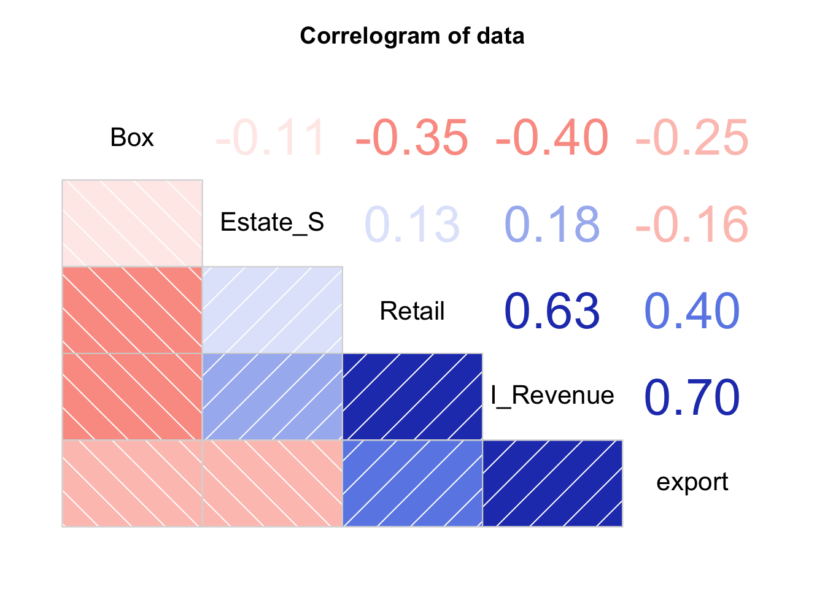

The correlation matrix above shows the correlation between variables, whose lower triangle indicates negative correlation as red boxes and positive correlation with blue boxes, while the upper triangle shows the correlation rate. We set a threshold of 0.9 to select pairs of highly correlated variables, and no variables should be expurgated.

## OLS model

While the VAR model shows us the relationship between variables with details of time change, the OLS model gives us a big picture of how a factor variate with another across the time line. Therefore, before specifically focusing on the variations of data with respect to its lagged terms, we can look at the general trend from 2007 to 2020, that is, to see how RES, TRS and EXP changes with regard to the trends of other variables. A significant linear relationship of entire trends also indicates a possible linear relationship between their lagged terms, hence gives us an idea that whether or not a variable is appropriate to be added in our VAR models. The three OLS models are shown below:

$$\left\{\begin{aligned}Retail=a_{0}+a_{1}Estates+a_{2}I_Revenue+a_{3}BOX +a_{4}Estate_S + a_{5}export \\ Estates=b_{0}+b_{1}Retail+b_{2}I_Revenue+b_{3}BOX +b_{4}Estate_S + b_{5}export \\ export=c_{0}+c_{1}Retail+c_{2}I_Revenue+c_{3}BOX +c_{4}Estate_S + c_{5}Estates\end{aligned}\right.$$

where $a_{0}$ and $b_{0}$ and $c_{0}$ are the intercept, and each of $c_{1}to c_{3}$*, $b_{1} to b_{3}$* and $a_{1}$ to $a_{3}$ is the coefficient for each variable. The results of regression are shown below.







Good news is that the Industrial Revenue has a significant positive linear relationship with all the three dependent variables, indicating a probable linear relationship that also occurs in their lagged terms as additional strong predictors in our models. Moreover, we notice that the Box office has a linear relationship with TRS, hence the Box office may be a good predictor for TRS. Even though its significance is not as strong as the Industrial Revenue has, we would still regard the Box office as a valuable data here because the variation of Box office could be seen as a sign of the public sentiment towards COVID-19, which will increase until the condition of the virus was generally considered eliminated. It is also a sign of economic recovery, since what would follow the recovery of the box office is the rise of consumptions in crowded places which accounts for a substantial amount of GDP, including public transportation fare and entertainment.

Among the three OLS variables, however, the largest R-Squared is 0.5435, meaning that the variation of the three demand variables may not be sufficiently captured by the other variables, even though we could find several significant terms in our result. Therefore, the addition of lagged variables is more crucial to make our models a better fit.

## VAR Model Diagnostics and Construction

Before applying the VAR model, we look at the stationarity and the autocorrelation of our data. Having stationary data is an ideal case for VAR models, while non-autocorrelation of variables is a strong assumption that should to be met as much as possible.

To deal with non-stationary data, we can transform them by differencing, that is, using the differences between consecutive observations instead of the observations themselves. We used Phillips–Perron test to test for the stationarity. Then we found that the variable “PPI” is the only data that shows non stationarity, indicating that the difference of consecutive observations of PPI is a better option to be used in VAR.

The Result of Phillips–Perron test shows the the p-values are less than 0.01. Noticing that the alternative hypothesis for this test is that the data is stationary, a small p-value less than 0.01 means that we reject the null hypothesis and conclude that the data is stationary.

To test the autocorrelation, I made a portmanteau test to know if the autocorrelation in the residuals of any variable is not equal to zero. As the p-value equals to 0.1494 when the number if lagged terms is 10, we fail to reject the null hypothesis and conclude that there is no autocorrelations in the residuals of variables.

 The result of portmanteau test by R Studio:

Then, we try to construct a model and discuss our findings. With the three variables representing the demand side of economy: $Retail$ and $Estate_S,$ we formed VAR models to know the predictors of each of the variable, and then we predict the change of the three variables in the following 12 month, with the 95% confidence interval.

The AIC recommend the number of lags to be 2. Therefore, the VAR model we constructed performs as:

$$Estate_S =\sum_{k=1}^{2}{(}β_{1}+ρ_{1k}Estate_S + ρ_{2k}Retail + ρ_{3k}export + ρ_{4k}Revenue_I + ρ_{5k}Box) \\ Retail =\sum_{k=1}^{2}{(}{β_{2}+θ}_{1k}Estate_S + θ_{2k}Retail + θ_{3k}export + θ_{4k}Revenue_I+ θ_{5k}Box )$$

$$export =\sum_{k=1}^{2}{(}{β_{3}+γ}_{1k}Estate_S+ γ_{2k}Retail + γ_{3k}export + γ_{4k}Revenue_I+ γ_{5k}Box )$$

Where $ρ_{1k}⋯⋯ρ_{11k}$, where k has the range from 1 to 2, represent the coefficients of lagged terms, so do $θ_{1k}⋯⋯θ_{11k}$ and $γ_{1k}⋯⋯γ_{11k}$. $β's$ are the intersects for each equation.

## VAR Model Forecasting Result

 Using all the variables with the first and second lagged terms, we can forecast the trend of the three variables within the next 12 months with 95% confidence interval, from August 2020 to July 2021. From the results below, we notice that the R-Squared for each model ranges from 0.6 to 0.7, which means that by using the data that we have, we can predict 60% to 70% of the variations of TRS, RES and EXP. It indicates that though our models may not be used for the specific description of every variation in economy, it can at least be used for predicting a broad trend of economy for the next year.



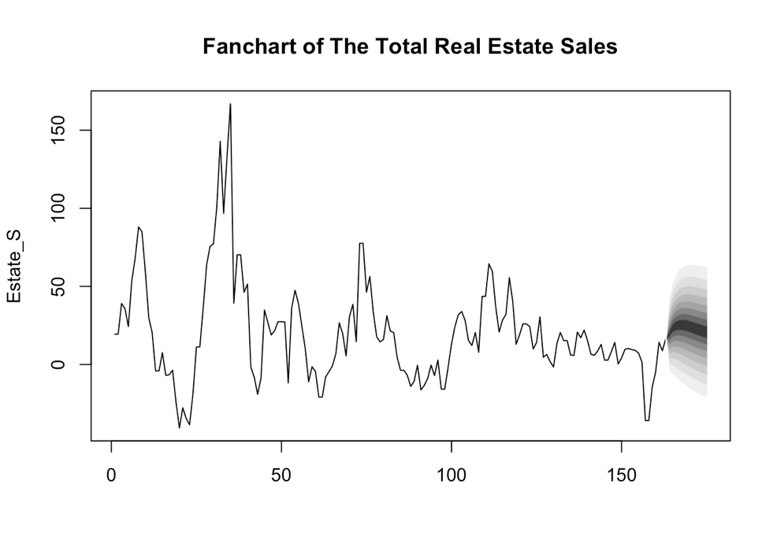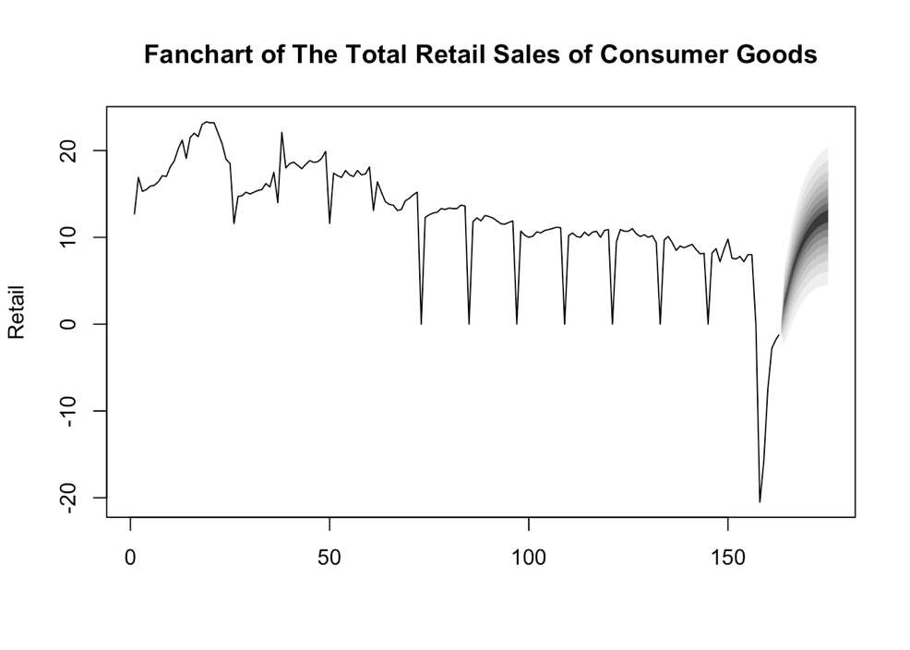 By using these three models, we can graphically describe the prediction results for the three variables of interest. We can tell that more or less, all the three variables will experience an increasement, meaning that the demand side of economy in the next 12 months will continue recovering to a normal stage or even a better stage. Specifically, the percentage increase in TRS, RES and EXP in August 2021 will be 12%, 20%, and 10% respectively, in a year-to-year ratio.

## /var/folders/71/nvb2lpzd3rb2j1xlchywpwsw0000gn/T/com.microsoft.Word/Content.MSO/86D73D16.tmpDiscussion

From the result of VAR model forecasts, we may notice a recovery trend of the total retail sales, while the total fixed asset investment and the total real estate sales are still in an oscillating condition. However, if comparing each variable with its average value in 2019 with total fixed asset investment equals to 5.47; total estate sales equals to 6.66; total retail sales equals to 7.38, we would find that the former two have its forecasted value in 2021 July at least higher than the average of 2019, while the latter one have its forecasted value lower than the past average.

The table below shows the historical trend of the three variables. We can notice that all of them have plummeted at the beginning of year 2020. While the condition of the fixed asset investment and the real estate sales have recovered in a relatively fast pace, that of the total retail hasn’t been closed to the level before the outbreak of COVID-19. This trend can help explain our forecasts result: the total retail sales is increasing steadily, but it doesn’t fully recover since it increases in a slow pace; the other two variables have recovered more exhaustively, hence the oscillation may be a regular variation just as their past trends usually perform.

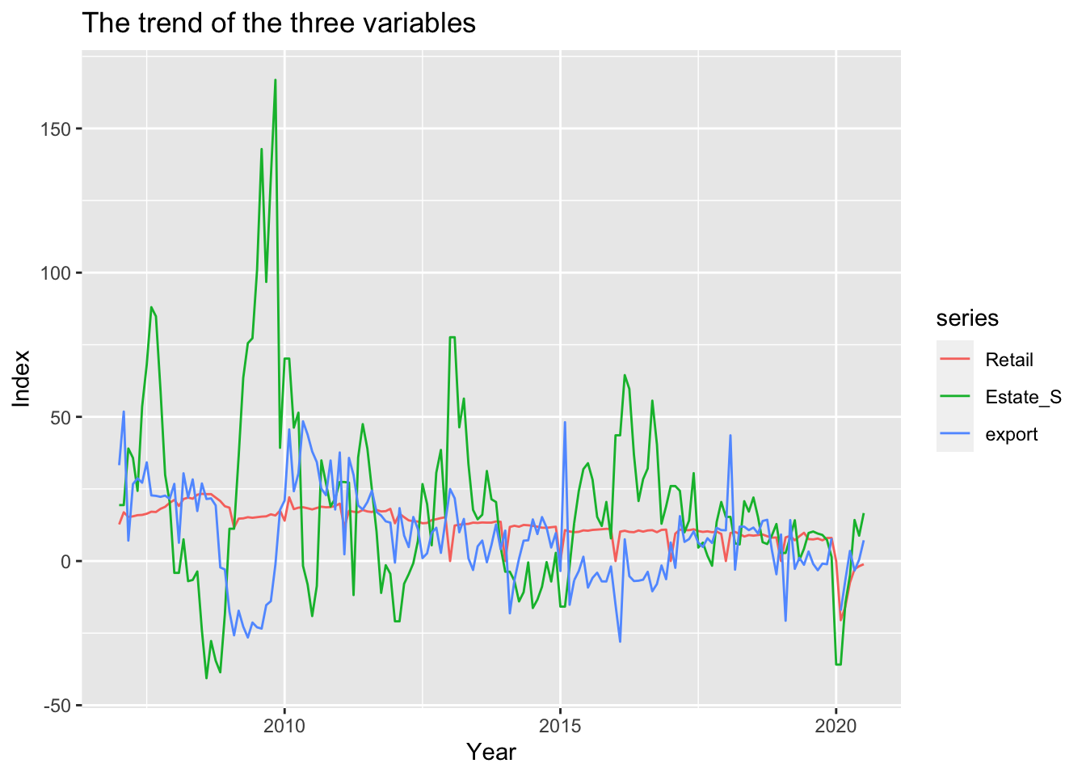

Therefore, the recovery of China’s economy may be more thorough as the total retail sales get back to a normal status. There are various reasons to explain the lagging recovery of total retail sales. One of the reasons could be the unemployment during the quarantine as we mentioned, and the different types if retail sales is also worth considering when identifying the key of its lagging recovery.

References

Cai, Chunlin. (n.d.). [Industry Watch in the post-epidemic era] The catering industry that has been hit by "precision strikes" may usher in a "big shakeout “. Retrieved September 27, 2020, from http://news.cctv.com/2020/04/26/ARTIHBdRnNfGE2lGDjQBQsrU200426.shtml

Chen, J. (2020, August 28). What Is an Economic Growth Rate? Retrieved September 27, 2020, from https://www.investopedia.com/terms/e/economicgrowthrate.asp

Finance Sina. (2020, July 21). Ren Zeping interprets economic data: China's economic recovery leads the world, but the situation is still grim. Retrieved September 27, 2020, from <https://finance.sina.cn/zl/2020-07-21/zl-iivhvpwx6579942.d.html?from=wap>

Gharehgozli, O., Nayebvali, P., Gharehgozli, A. et al. Impact of COVID-19 on the Economic Output of the US Outbreak’s Epicenter. EconDisCliCha (2020). <https://doi.org/10.1007/s41885-020-00069-w>

Guerrieri, V., Lorenzoni, G., Straub, L., & Werning, I. (2020). Macroeconomic implications of COVID-19 can negative supply shocks cause demand shortages? Cambridge, MA: National Bureau of Economic Research.

Vector Autoregressive Models for Multivariate Time Series. (2006). In: Modeling Financial Time Series with S-PLUS®. Springer, New York, NY. https://doi.org/10.1007/978-0-387-32348-0_11

VAR模型用来预测

OLS模型GDP~x y z；找代表经济增长变量

还原成季度数据；用GDP增数

投资-固投；房地产销售

消费-零售总额

进出口